**Performance Test Report**

**Test Summary:**

Test Execution Date: 21-Dec-2018

Load test has been executed for the below APIs with 100 Virtual Users each. Packet Server API is tested with a small PDF file and a larger file. Email Notification API test will be conducted with next schedule as it was down on 21st Dec.

**Test Observations:**

1. During the run, Audit Manager was getting 500 internal server error close to 6%.
2. The number of UIN numbers generated per second is 26.15.
3. Packet Server returned error while trying to upload the file which is more than 5MB. The error is “Response code: Non HTTP response code: org.apache.http.ConnectionClosedException

Response message: Non HTTP response message: Premature end of chunk coded message body: closing chunk expected”

**Transaction Summary:**

|  |  |  |  |  |  |  |  |
| --- | --- | --- | --- | --- | --- | --- | --- |
| **Label** | **#Sample** | **Average(ms)** | **90% line(ms)** | **Min(ms)** | **Max(ms)** | **Error%** | **Throughput** |
| UIN_Generator_Request | 59244 | 2574 | 2746 | 96 | 42043 | 0.06% | 26.15 |
| Audit Manager Request | 122938 | 727 | 605 | 54 | 899759 | 5.67% | 49.74 |
| OTP_Generation | 35509 | 472 | 292 | 66 | 42026 | 0.00% | 15.80 |
| OTP_Validation | 35469 | 497 | 245 | 52 | 42023 | 0.08% | 15.81 |
| Packet_Server_with_1.5MB | 7569 | 26280 | 38508 | 1050 | 78090 | 0.50% | 3.36 |
| Packet_Server_with_3.84MB | 2576 | 81445 | 111347 | 1994 | 162164 | 0.23% | 1.14 |

1. **UIN Generator**

|  |  |
| --- | --- |
| Kernel Request | UIN_Generator |
| Base URL | https://integ.mosip.io |
| Execution Window | 2018/12/21 11:32 AM IST to 2018/12/21 12:02 PM IST |
| Maximum User Load | 100 |
| Tool Used | Jmeter |
| Average Response Time | 2574 |
| Throughput Achieved | 26.15 Req Per Sec |

Response Times Over Time:

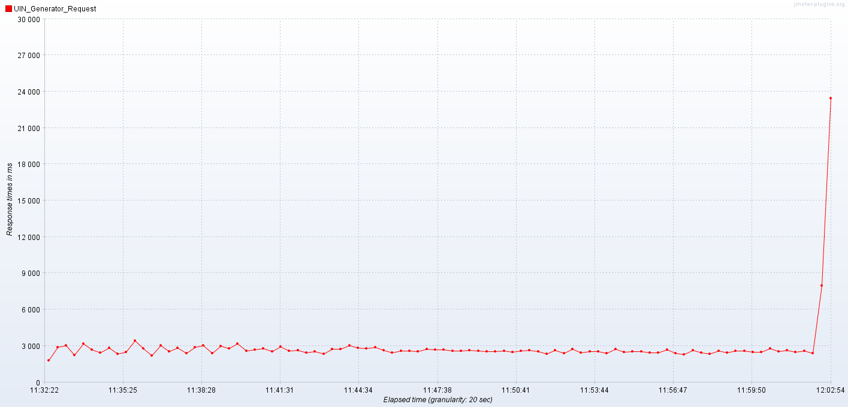

Bytes Throughput Over Time:

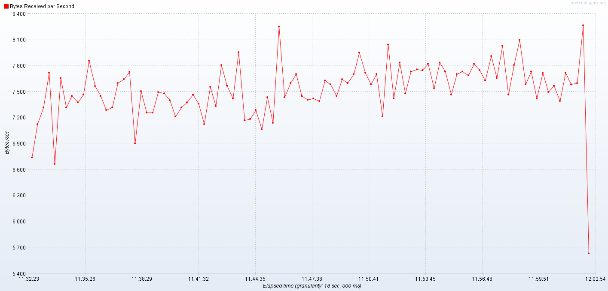

1. **Audit Manager**

|  |  |
| --- | --- |
| Kernel Request | Audit Manager Request |
| Base URL | https://integ.mosip.io |
| Execution Window | 2018/12/21 12:32 AM IST to 2018/12/21 01:03 PM IST |
| Maximum User Load | 100 |
| Tool Used | Jmeter |
| Average Response Time | 727 ms |
| Throughput Achieved | 49.74 Req per Sec |

Response Times Over Time:

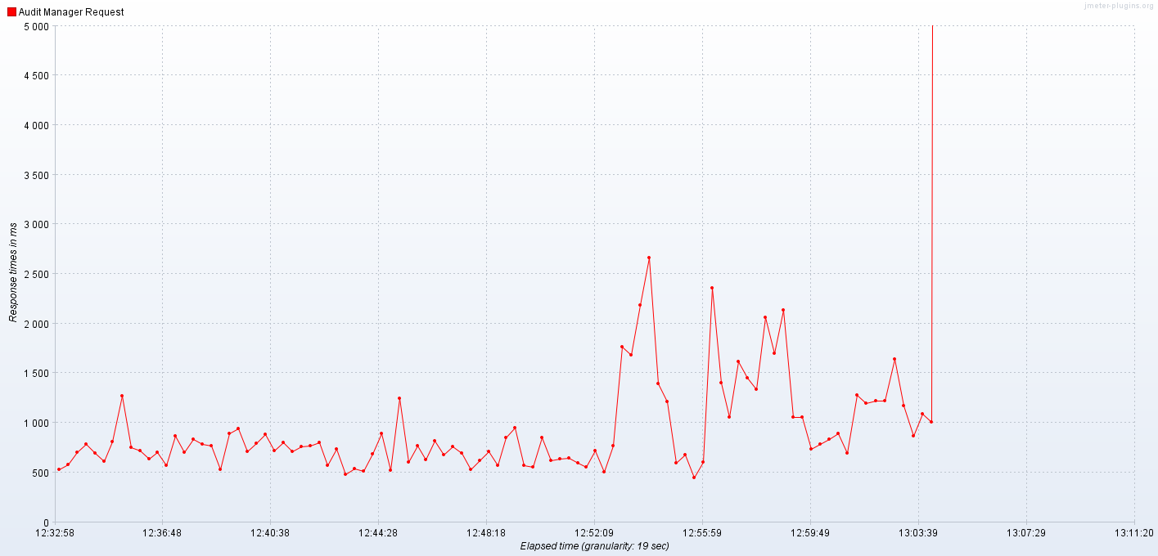

Bytes Throughput Over Time:

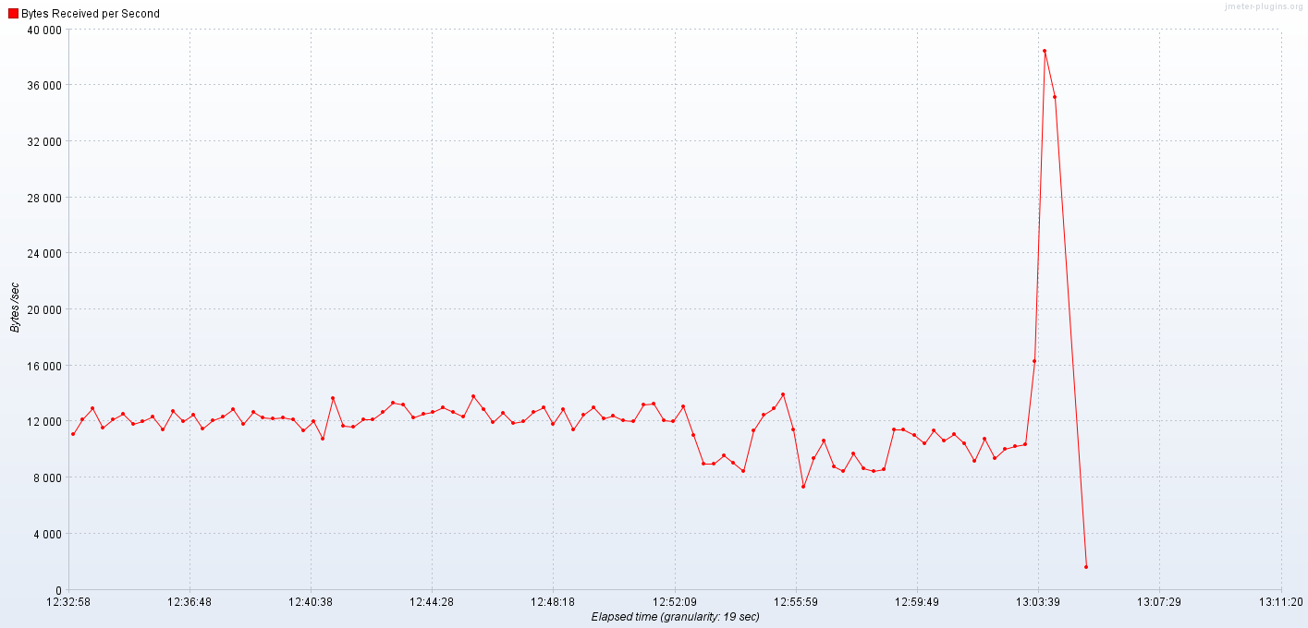

1. **OTP Manager**

3.1 OTP_Generation

|  |  |
| --- | --- |
| Kernel Request | OTP_Generation |
| Base URL | https://integ.mosip.io |
| Execution Window | 2018/12/21 01:25 AM IST to 2018/12/21 01:55 PM IST |
| Maximum User Load | 100 |
| Tool Used | Jmeter |
| Average Response Time | 472 ms |
| Throughput Achieved | 15.8 Req per Sec |

Response Times Over Time:

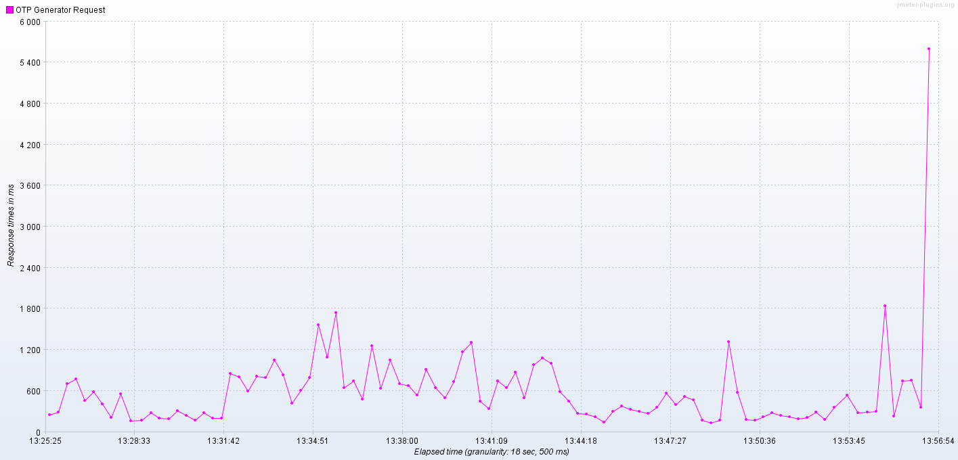

Bytes Throughput Over Time: (OTP_Generation + OTP Validation)

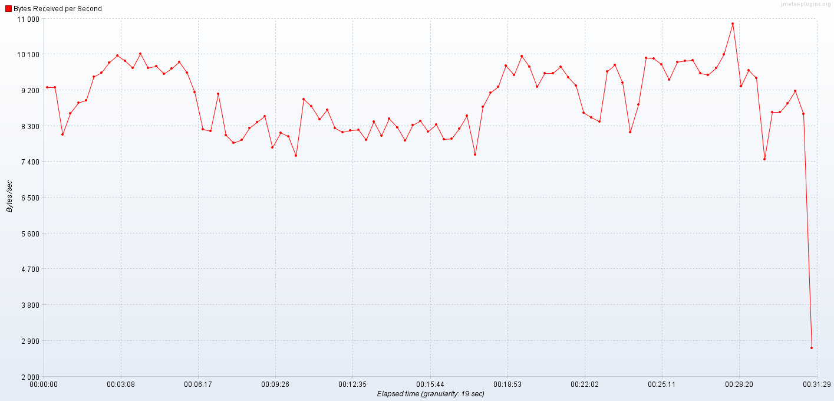

3.2 OTP Validation:

|  |  |
| --- | --- |
| Kernel Request | OTP_Validation |
| Base URL | https://integ.mosip.io |
| Execution Window | 2018/12/21 01:25 AM IST to 2018/12/21 01:55 PM IST |
| Maximum User Load | 100 |
| Tool Used | Jmeter |
| Average Response Time | 497 |
| Throughput Achieved | 15.8 Req per Sec |

Response Times Over Time:

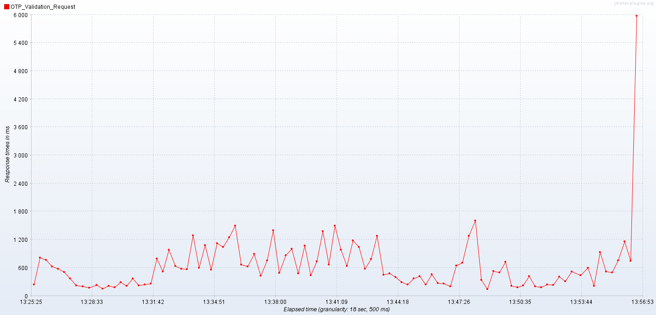

1. **Packet_Server_with_1.5MB**

|  |  |
| --- | --- |
| Kernel Request | Packet_Server_with_1.5MB |
| Base URL | https://integ.mosip.io |
| Execution Window | 2018/12/21 03:03 AM IST to 2018/12/21 03:33 PM IST |
| Maximum User Load | 100 |
| Tool Used | Jmeter |
| Average Response Time | 26280 |
| Throughput Achieved | 3.36 Req per sec |

Response Times Over Time:

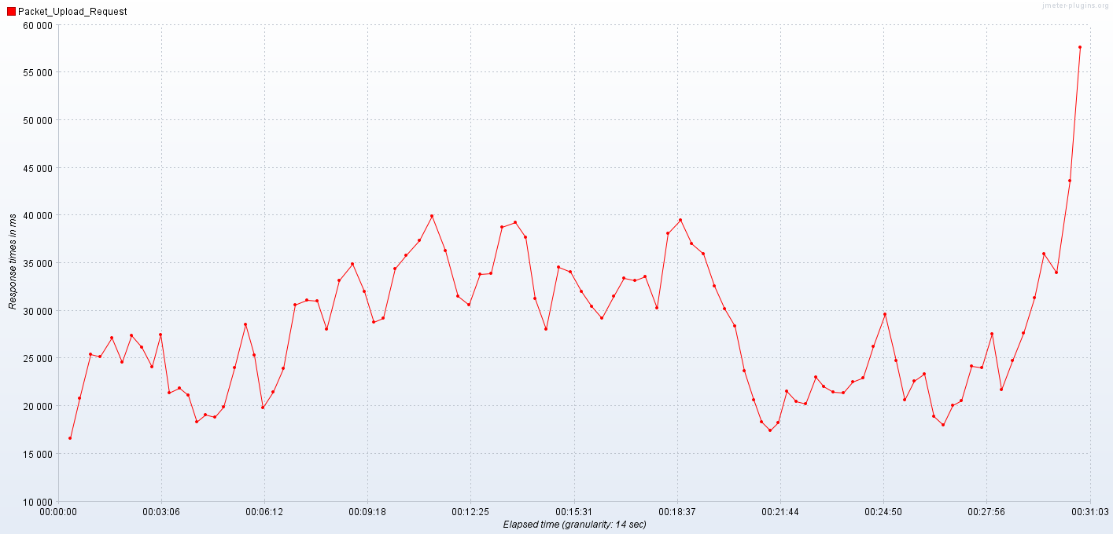

Bytes Throughput Over Time:

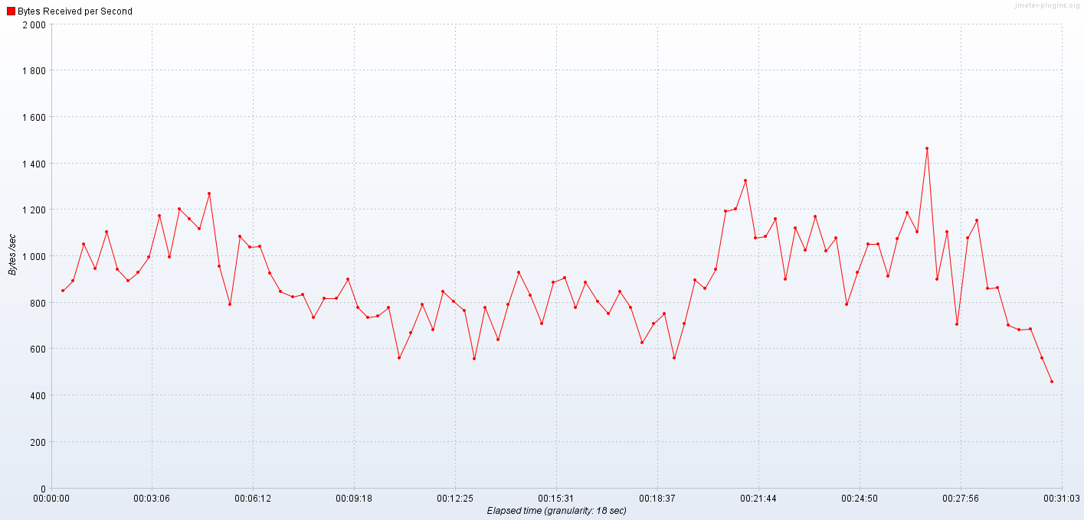

1. **Packet_Server_with_3.84MB**

|  |  |
| --- | --- |
| Kernel Request | Packet_Server_with_3.84MB |
| Base URL | https://integ.mosip.io |
| Execution Window | 2018/12/21 04:19 AM IST to 2018/12/21 04:49 PM IST |
| Maximum User Load | 100 |
| Tool Used | Jmeter |
| Average Response Time | 81445 |
| Throughput Achieved | 1.14 Req per Sec |

Response Times Over Time:

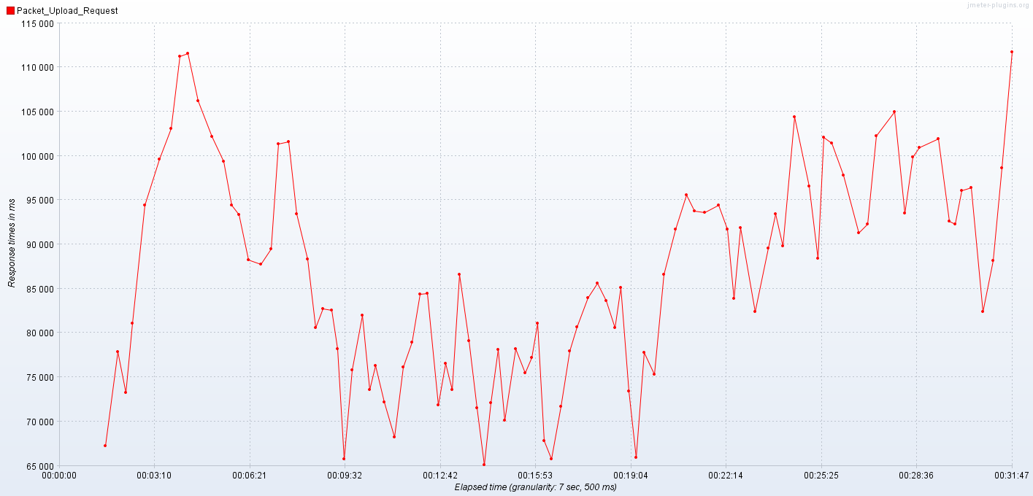

Bytes Throughput Over Time:

